**SSN College of Engineering**

**Department of Computer Science and Engineering**

**UCS1512 – Microprocessors Lab**

**EX:04 - CODE CONVERSION**

**Exp No: 04 Name : Kshitij Sharma**

**Date: 17/09/2020 Reg No: 185001080**

**Aim:-**

To write and execute 8086 ASL programs for conversion from BCD to Hexadecimal and Hexadecimal to BCD

# Algorithm:-

1. **BCD to Hexadecimal:**
   * Move the data segment to the AX register. Then move it to the DS register.
   * Move BCD value into BL register.
   * Perform bitwise AND operation on BL with 0Fh to keep the lower nibble.
   * Load BCD value into AL.
   * Perform bitwise AND operation on AL with F0h to keep the higher nibble.
   * Shift AL to the right by 4 bits
   * Store 0Ah in DL.
   * Multiply AL with DL
   * Add AL with BL.
   * Move AL to HEX.

# Hexadecimal to BCD:

* + Move the data segment to the AX register. Then move it to the DS register.
  + Move 00h to AH register.
  + Move HEX value to AL register.
  + Move 64h (hex value for 100) to CL register.
  + Divide AX by BL.
  + Move quotient in AL to BCD1.
  + Move the remainder in AH to AL.
  + Move 00h to AH.
  + Move 0Ah (hex value for 10) to BL.
  + Divide AX by BL.
  + Left rotate the quotient in AL by 4 bits.
  + Move AH to DL
  + Perform bitwise OR of DL and AL.
  + Move DL to BCD2.

# Program:-

**1. BCD to Hexadecimal:**

|  |  |
| --- | --- |
| **PROGRAM** | **COMMENTS** |
| MOV AX,DATA | Transfer the data to ax register |
| MOV DS,AX | Transfer the the value of ax register to data segment register |
| MOV BL,BCD | Transfers BCD value to BL register. |
| AND BL,0FH | Performs Bitwise AND of BL and 0F.(To extract lower nibble). |
| MOV AL,BCD | Transfers BCD value to AL register. |
| AND AL,0F0H | Performs Bitwise AND of AL and F0.(To extract higher nibble). |
| MOV CL,04H | Load value 04h in CL register. |
| ROR AL,CL | Rotate AL register by the number of bits specified by CL. |
| MOV DL,0AH | Load value 0Ah in DL. |
| MUL DL | AX = AX * DL |
| ADD AL,BL | AL = AL + BL |
| MOV HEX,AL | Transfers the value of AL to HEX |
| MOV AH,4CH | Loads 4ch value in ah register |
| INT 21H | Interrupts the Program |

**Snapshot:-**

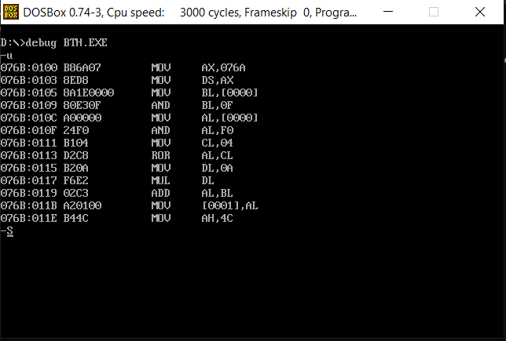

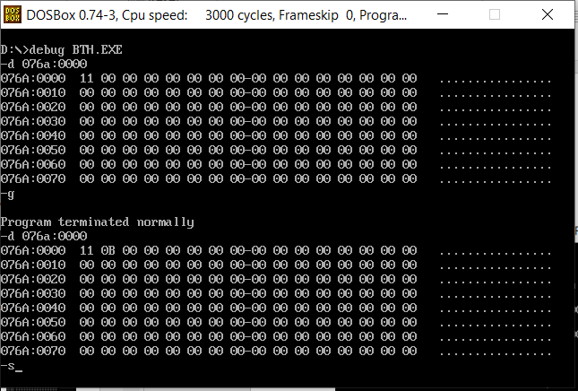

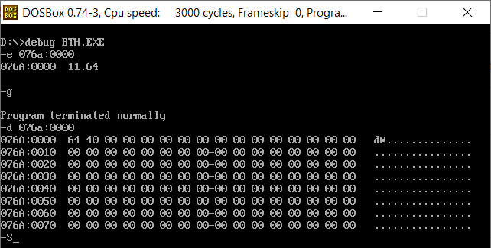

**2. Hexadecimal to BCD :**

|  |  |
| --- | --- |
| **PROGRAM** | **COMMENTS** |
| MOV AX,DATA | Transfer the data to ax register |
| MOV DS,AX | Transfer the the value of ax register to data segment register |
|  |  |
| MOV AH,00H | Transfers the value 00h to AH register. |
| MOV AL,HEX | Transfers HEX value to AL register. |
| MOV BL,64H | Load value 64h in BL register. |
| DIV BL | AX = AX/BL |
| MOV BCD1,AL | Transfer the value of AL register to BCD1 |
| MOV AL,AH | Transfer the value of AH to AL |
| MOV AH, 00H | Load 00h in AH register |
| MOV BL, 0AH | Load 0Ah in BL register |
| DIV BL | AX = AX /BL |
| MOV CL,04H | Load 04h value in CL register. |
| ROL AL,CL | Rotate AL register by the number of bits specified by CL. |
| MOV DL,AH | Transfer the value of AH to DL |
| OR DL,AL | Performs bitwise OR on DL and AL. |
| MOV BCD2,DL | Transfer the value of DL to BCD2 |
|  |  |
| MOV AH,4CH | Loads 4ch value in ah register |
| INT 21H | Interrupts the Program |

**Snapshot:-**

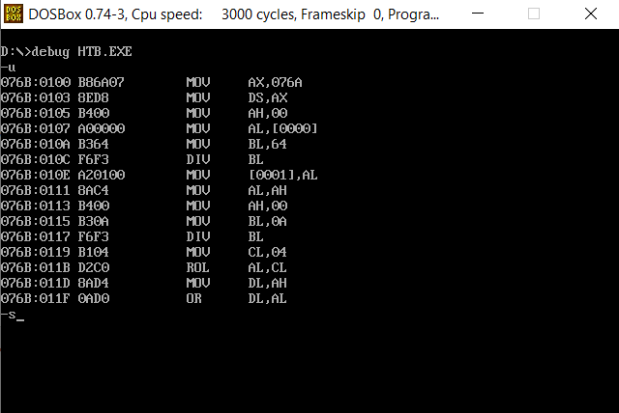

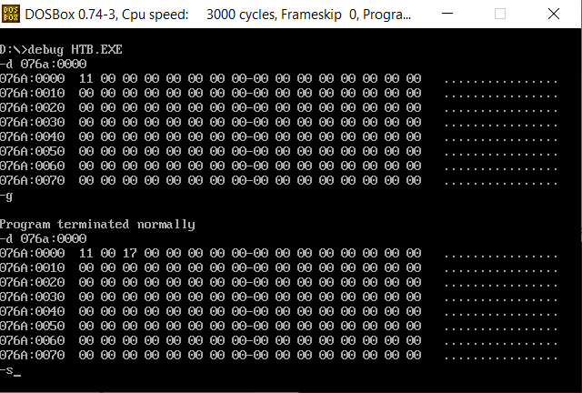

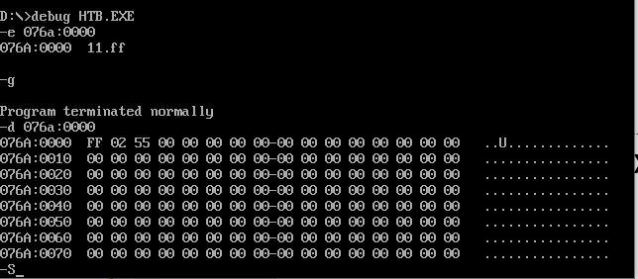

**Result:-**

Thus the 8086 ALP for code conversions such as BCD to HEX and HEX to BCD have

been implemented successfully using MS-DOSBOX.